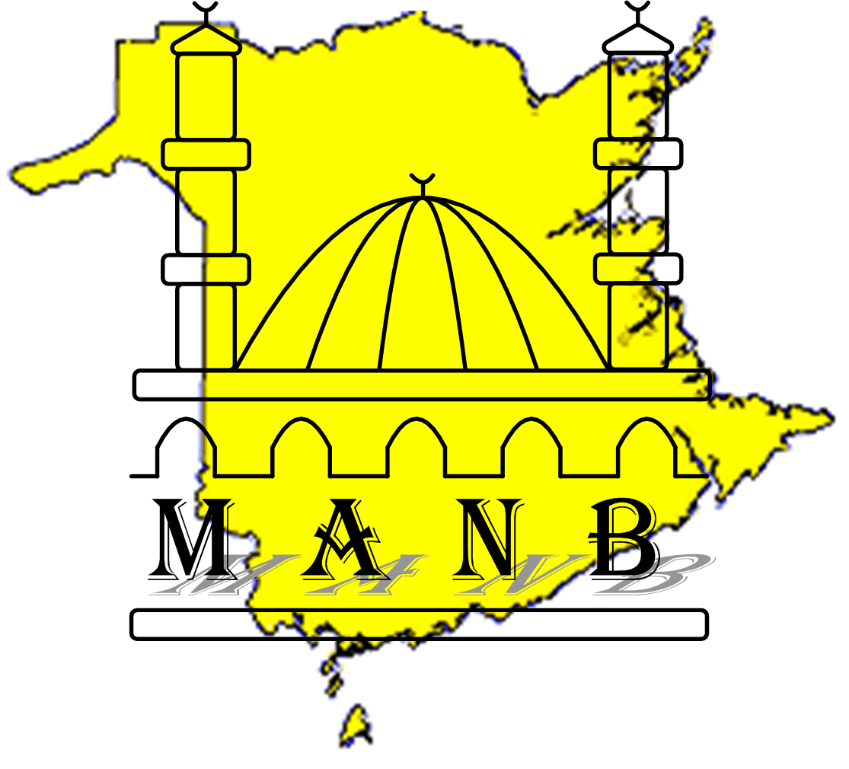
Muslim Association of New Brunswick
1100 Rothesay Road
Saint John, NB E2H 2H8
CANADA
(506) 633-1675
www.manb.ca
In the Name of God, the Compassionate, the Merciful

STUDENT APPLICATION FORM - MANB ISLAMIC SCHOOL
One family per sheet please. Do not register your son or daughter on the same sheet as your friend's sheet

Please take time to read the information below before filling the Registration form
Madrassa Fee is:
- $125 Per Child
- $350 per family ( 3 or more children)
- Sponsorship is available for needy families. Please email us or contact the teachers or Administrator with details
- The Fee for Children registering after December 31st will be prorated.

IMPORTANT NOTICE
I, |  |  | acknowledge that I have voluntarily enrolled my child to participate in the Activities below
 | (Name of parent/guarantor)
In the MANB Islamic School, Children will be asked to participate in the following activities at the Islamic School:
1. Classroom sessions that teach the Arabic language
2. Classroom sessions that teach Islamic values
3. Classroom sessions that teach the recitation/memorization of Qur'an
4. Sessions that teach the child to pray
I AM ALSO AWARE THAT CURRICULUM MATERIAL BEING TAUGHT TO MY CHILD, IS ONE THAT ADHERES TO THE OBJECTIVES OF THE MUSLIM ASSOCIATION OF NEW BRUNSWICK (MANB) CONSTITUTION, WHICH IS CONSISTENT WITH THE TEACHINGS OF THE HOLY QURAN AND THE AUTHENTIC TRADITION OF PROPHET MUHAMMAD (PEACE AND BLESSING BE UPON HIM).
5. Gym activities
6. Outdoor recreational activities
7. Special events which celebrate different Islamic Holidays. These activities are optional and will be held outside of normal classroom activities. Activities may include but are not limited to bowling, kids playgrounds, water sports, going to restaurants …)
I AM AWARE THAT SOME OF THESE ACTIVITIES MAY BE HAZARDOUS ACTIVITIES AND COULD CAUSE SERIOUS INJURY. I AM VOLUNTARILY ENROLLING MY CHILD IN THESE ACTIVITIES WITH KNOWLEDGE OF THE POTENTIAL RISKS AND DANGER INVOLVED, AND AGREE TO ASSUME ANY AND ALL RISKS OF BODILY INJURY, DEATH OR PROPERTY DAMAGE, WHETHER THOSE RISKS ARE KNOWN OR UNKNOWN.
I verify this statement by placing my signature here:
WAIVER FORM

I agree and Permit my Child ----------------------------------------------------------------------------- to Participate in the MANB Madrassa and its activities and use the facilities. I forever release the Islamic School, the Muslim Association of New Brunswick, the Lessor, and any of their respective directors, officers, employees, volunteers, agents, contractors, and representatives (collectively “Releases”) from any and all actions, claims, or demands that I, my assignees, heirs, distributes, guardians, next of kin, spouse and legal representatives now have, or may have in the future, for injury, death, or property damage, related to (I) my child’s participation in these activities, (ii) the negligence or other acts, whether directly connected to these activities or not, and however caused, by any Release, or (iii) the condition of the premises where these activities occur, whether or not my child is then participating in the activities. I also agree that I, my assignees, heirs, distributes, guardians, next of kin, spouse and legal representatives will not make a claim against, sue, or attach the property of any Release in connection with any of the matters covered by the foregoing release.
I HAVE CAREFULLY READ THIS AGREEMENT AND FULLY UNDERSTAND ITS CONTENTS. I AM AWARE THAT THIS IS A RELEASE OF LIABILITY
AND A CONTRACT BETWEEN MYSELF AND THE ISLAMIC SCHOOL, THE MUSLIM ASSOCIATION OF NEW BRUNSWICK AND THE LESSOR, AND
SIGN IT OF MY OWN FREE WILL.
PARENT OR GUARDIAN
 |  |  |  |  | 5/30/2010
Parent / Guardian Signature

REGISTRATION FORM
How Many Children are you Registering : _________________________________
Mother's name ______________________________ phone number ________________
e-mail address __________________________________
Father's name ____________________________ phone numbers ________________
mail address __________________________________
Address ____________________________________________________________________
Primary Spoken language: __________________ Mother Tongue: -------------------------------------
Emergency Contact's name __________________ phone numbers ________________
CHILD #1
First Name: --------------------------------------- Last Name: ______________________________
Date of Birth : _______________________ Sex : Male ____ Female _____
Has the child Attended Islamic Education: YES NO
Can the child read Arabic version of the Quran? YES NO
List Allergies Child has/or Special needs to keep on File: __________________________________________________________________________________

CHILD #2
First Name: --------------------------------------- Last Name: ______________________________
Date of Birth : _______________________ Sex : Male ____ Female _____
Has the child Attended Islamic Education: YES NO
Can the child read Arabic version of the Quran?? YES NO
List Allergies Child has/or Special needs to keep on File:
__________________________________________________________________________________
___________________________________________________________________________________
CHILD #3
First Name: --------------------------------------- Last Name: ______________________________
Date of Birth : _______________________ Sex : Male ____ Female _____
Has the child Attended Islamic Education: YES NO
Can the child read Arabic version of the Quran? YES NO
List Allergies Child has/or Special needs to keep on File:
__________________________________________________________________________________

CHILD #4
First Name: --------------------------------------- Last Name: ______________________________
Date of Birth : _______________________ Sex : Male ____ Female _____
Has the child Attended Islamic Education: YES NO
Can the child read Arabic version of the Quran? YES NO
List Allergies Child has/or Special needs to keep on File:
__________________________________________________________________________________

